A closer look at es6

Const

* **They are block scoped**
* **The value of a constant cant be changed through code**
* **Use this when you want a variable that never changes**

**Arrow functions**

* An arrow function expresses a compact alternative. It is limited and can’t be used in all situations
* Arrow functions don’t have their own bindings to this, arguments or super
* Do not use as method
* Arrow functions cannot be used as constructors

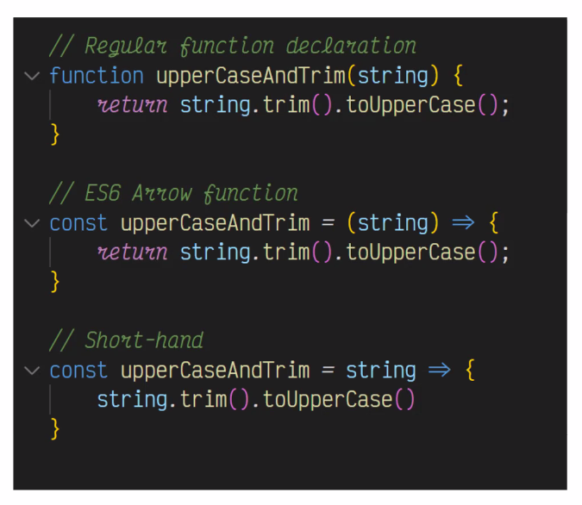

Spread Operator (…)

* Spread allows an iteratable to combine objects
* Can be used to clone an object or merge arrays

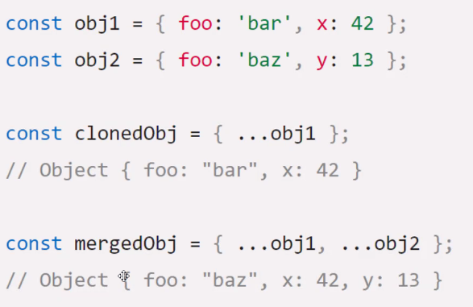

For … of

* This statement executes a loop that operates on a sequence of values sourced from an iterable object

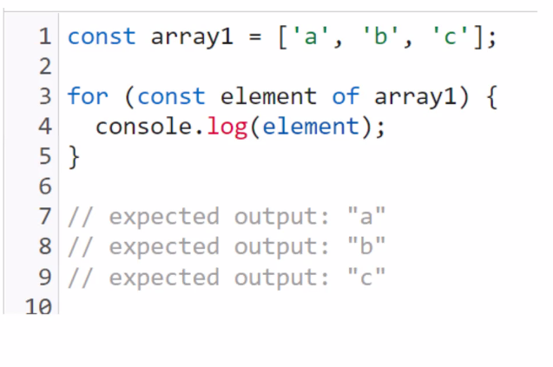

* Arrays.entry()

Default parameters

**Promises!**

* **The promise object represents the eventual completion( or failure) of an asynchronous operation and its resulting values**
* **A promis is proxy for a value not necessarily known when the promis is created. It allows you to associate handlers with an asynchomous action’s eventual success calue or failure reason**
* 